Rafael V. Canseco

SNHU

CS-340

4-1 Milestone

09/29/24

Create and Read in Python

1. Upload the Austin Animal Center (AAC) Outcomes data set into MongoDB by importing a CSV file using the appropriate MongoDB import tool. This file is in the /usr/local/datasets/ directory in Apporto; the filename is “aac_shelter_outcomes.csv.” Use the database name “AAC” and collection name “animals.” Complete the import using the mongoimport tool, and take screenshots of both the import command and its execution.A computer screen with a black background

   Description automatically generated
2. Next, you must develop a Python module in a PY file using object-oriented programming methodology to enable create and read functionality for the database. Other Python scripts must be able to import your Python code as a module to support code reusability. Develop a CRUD class that, when instantiated, provides the following functionality:
   1. A method that inserts a document into a specified MongoDB database and collection
      1. Input argument to function will be a set of key/value pairs in the data type acceptable to the MongoDB driver insert API call
      2. Return “True” if successful insert, else “False”
   2. A method that queries for documents from a specified MongoDB database and collection.
      1. Input arguments to function should be the key/value lookup pair to use with the MongoDB driver find API call.
      2. 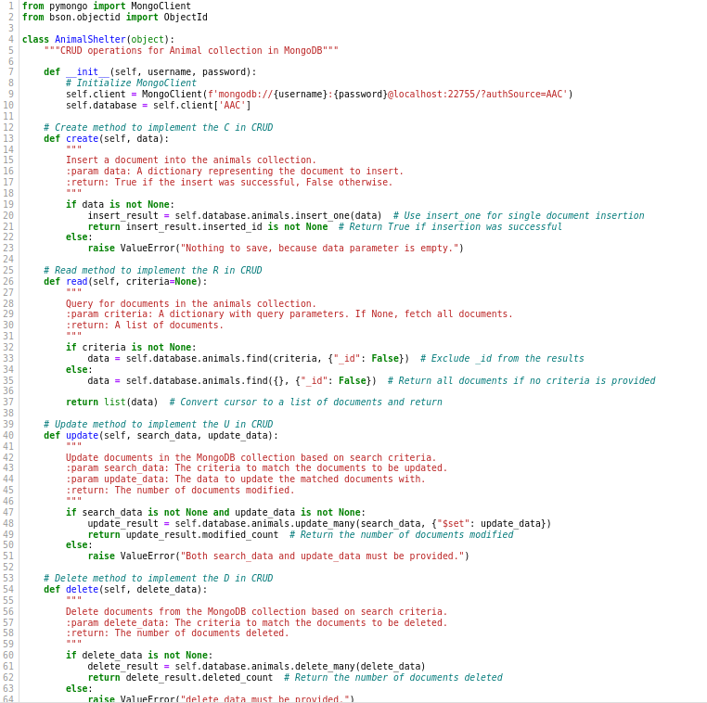Return result in a list if the command is successful, else an empty list..
3. Finally, create a Python testing script in Jupyter Notebooks that imports your CRUD Python module to call and test the create and read instances of CRUD functionality. Be sure to use the username and password for the “aacuser” account for authentication when instantiating the class. This script should be created in a separate Jupyter Notebook IPYNB file and should import and instantiate an object from your CRUD library to affect changes in MongoDB. After creating your script, execute it in Jupyter Notebook and take screenshots of the commands and their execution.A screenshot of a computer program

   Description automatically generated